TMT/Tenali/S0610/2025 15.12.2025

To,
Srinivas,
Mobile: +91 63029 24898,
Tenali.

Dear Sir

SUB:- SUPPLY OF 200 Ton H TYPE HYDRAULIC PRESS

With reference to our discussions regarding your requirement for press. we are glad to inform you that, we are in a position to supply you the required equipment. The following are the specifications and our terms and conditions.

Specifications of the equipment

Technical Specifications :-

Pressing cylinder

❖ Max Working Pressure - 200 Kg/cm2
❖ Normal Working Pressure - 160 Kg/cm2
❖ Design Pressure - 250 Kg/Cm2
❖ Tonnage at 160 Kg/cm2 - 200 Tons
❖ Cyl Bore - 340 mm
❖ Rod Dia - 150 mm
❖ Stroke - 350 mm
❖ Mtg - Front Flange
❖ Approach Speed - 35 mm/sec
❖ Pressing Speed - 0-5 mm/sec
❖ Return Speed - 44 mm/sec
❖ HP - 20 HP
❖ Tank Cap - 250 Ltr

Detail Bill of Material

❖ Cylinder Seals - Imported German Seals ( Merkel or Halite )
❖ Motor - ABB / Siemens / Kirloskar / Crompton
❖ Rod Seal - Imported halite Seal
❖ Valves - Yuken / Polyhydron / Hydrotech
❖ Check Valves - Polyhydron
❖ Hydraulic Pump - Yuken / Dowty
❖ High Pr Pump - Polyhydron
❖ Bell Housing - Micro
❖ Relief Valves - Polyhydron
❖ Hyd Tank - Micro
❖ Hyd Tank - MHPL
❖ Fitting - Hyloc / Hydair
❖ Gasket - Champion
❖ Fastners - TVS / LPS

S No | Description of the unit | Offer
1. | H Frame 200 Ton hydraulic press with stroke 500 mm and daylight 500 mm bed size 1800x900 mm along with cylinder electrical panel and 7.5 Hp power pack. | Rs 12,00,000/- (Rupees twelve Lakhs only)

GENERAL TERMS & CONDITIONS:

- Price quoted per unit ex-work. Hyderabad.
- Following charges are additional to your account.
- Freight Charge : As actual to be borne by you.
- Sales Tax : 18% Extra.
- Packing charge : As actual to be borne by you.
- Insurance : As actual to be borne by you.
- Payment : 50% advance along with order balance before delivery but after inspection at our works.
- Delivery : with in 1 months
- Validity : One month from the date of submission.
- Inspection : Inspection at our works prior to dispatch.
- Warranty : The machine is warranted for a period of 12 months from the date of dispatch against any manufacturing defects/ faulty material or bad workmanship of any part or component but not against any kind of abnormal or improper use of machine. Defective part or component will be replaced or repaired free of cost. Electrical components are outside the scope of this warranty.
- Commissioning : Erection & commissioning done by you, but required technical support & guidance provide by us at additional cost.
NOTE:
- Oil is not in scope of our supply.
- Raw material for trial is to be arranged by you at your cost.

We are sure you will find our offer in line with your requirements. Should you require any further clarification please contact 9246221106
Thanking you and assuring you of our best services

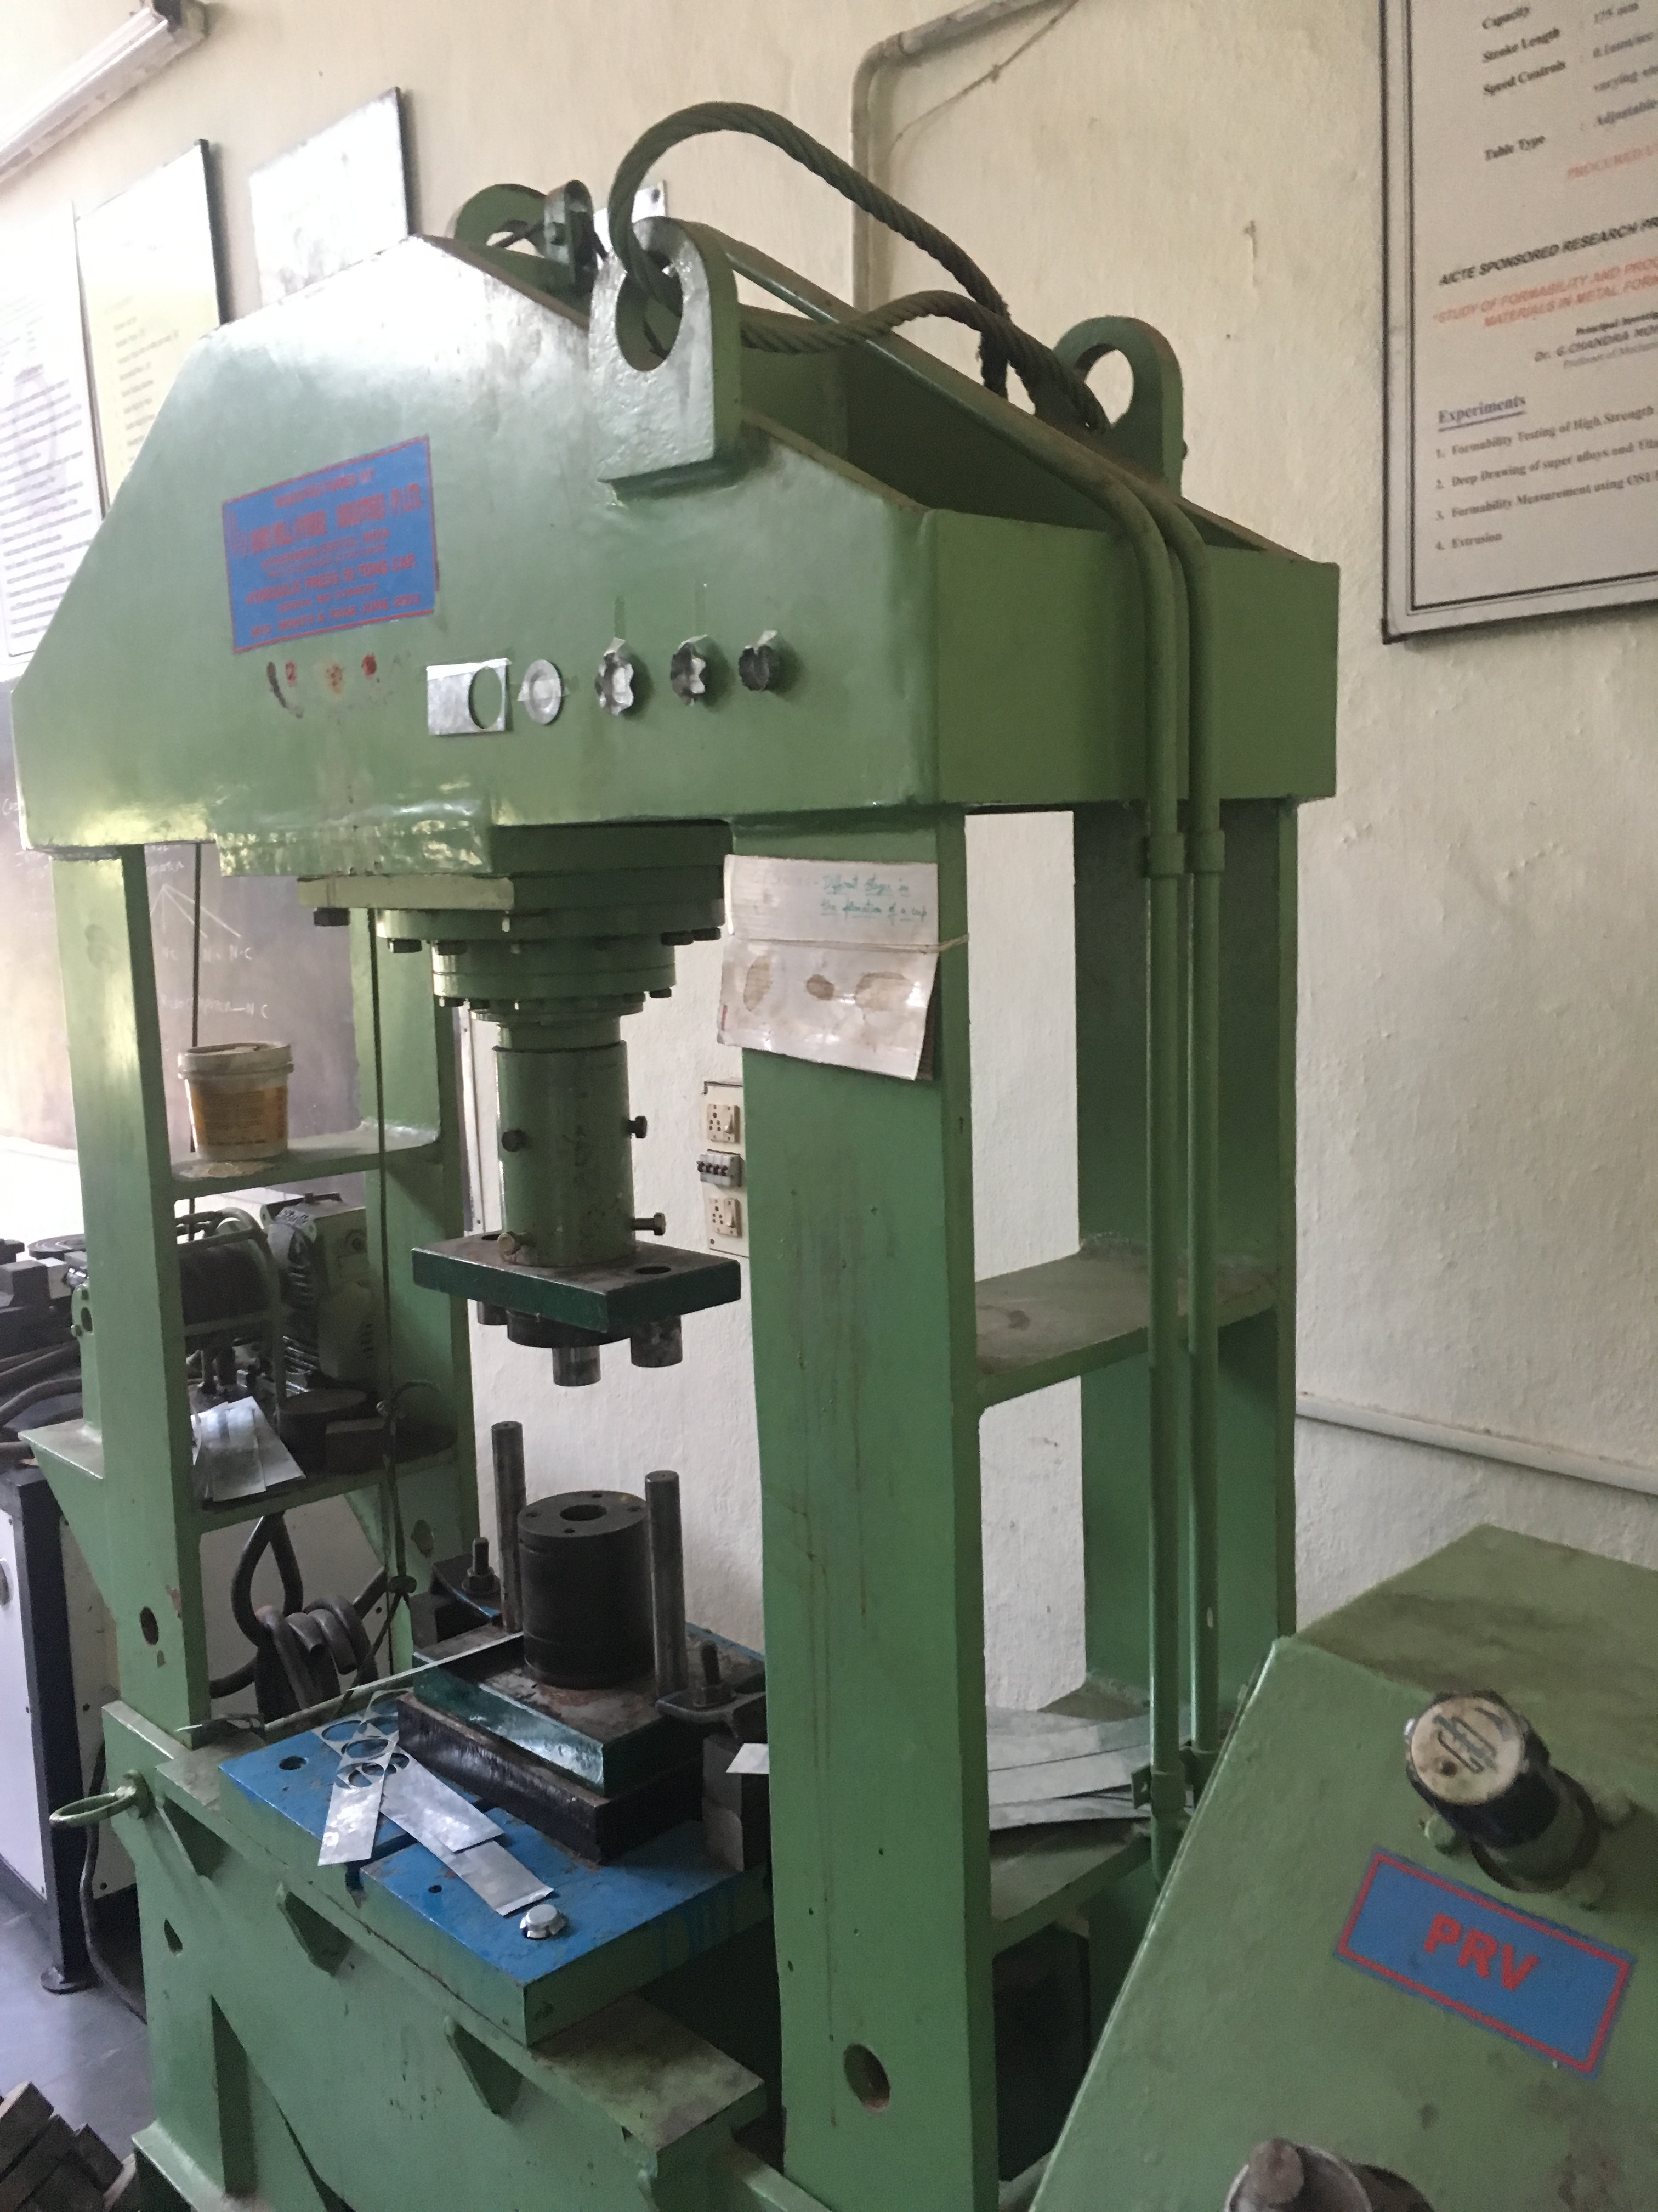

For TECHNO MACHINE TOOLS

T. SIVARAMAKRISHNA

